Bassetlaw Place Based Partnership – Communications and Engagement Strategy: Summer 2022

This strategy outlines the proposed communication and engagement activity for the Bassetlaw Place Based Partnership.
Since the Spring communications and engagement representatives from all Place partners have met fortnightly. New conversations have begun and developed, and we have adopted collaborative ways of working. Channels of communication have opened and new contacts have been made. We are now much more pro-active at sharing communications. We have a newsletter which partners regularly contribute to. We also have a matrix of communication channels available to all partners – both online and offline.
We are breaking down silo working and looking forward to communicating and engaging with people in Bassetlaw about Bassetlaw Place and the benefits it will bring to them.
In the last six months as a communications and engagement network, we have worked collaboratively on a variety of issues including:
- Move More in May
- Targeted lung health checks
- The Bassetlaw response to the Ukrainian conflict
- Covid vaccination messaging
- Suicide prevention
Communicating and engaging with our patients, partners, local communities, GPs and the voluntary sector is key to achieving our vision to improve health and wellbeing and reduce inequalities across Bassetlaw.
Communication and engagement will have an important role to play in supporting the Bassetlaw Place Based Partnership deliver on its objectives over the next year. We are focused on the way we communicate, engage and empower people in Bassetlaw. By working with partners across the health and social care system and Bassetlaw citizens, we aim to deliver the objectives laid out in this strategy.

BACKGROUND
The Bassetlaw Place Based Partnership is a collaboration of commissioners, health and care providers and local authorities and Healthwatch. The Partnership is working together to join health and care services across the district of Bassetlaw. The Partnership will ensure people in Bassetlaw receive simpler, integrated, responsive and well understood services to ensure they get the right support at the right time. This will support local people to stay well in their own homes and communities so everyone can be #BetterInBassetlaw.
Since July 1, 2022, Bassetlaw Place Based Partnership sits within the newly formed NHS Nottingham and Nottinghamshire Integrated Care Board, which itself is part of the county’s Integrated Care System (ICS).
The entire Nottingham and Nottinghamshire ICS footprint serves a population of just of more than 1.1-million people and covers a diverse community. The footprint across the county is a mix of urban and rural and includes communities from the highest and lowest levels of deprivation.
Bassetlaw sits at the north of Nottinghamshire. With a population of 116,000, it too has a diverse population. The towns of Worksop and Retford are home to almost 60 per cent of the district’s population with the remainder of citizens living in or around Bassetlaw’s 73 villages.

PRIORITIES
The key priorities for the Bassetlaw Place Based Partnership are:

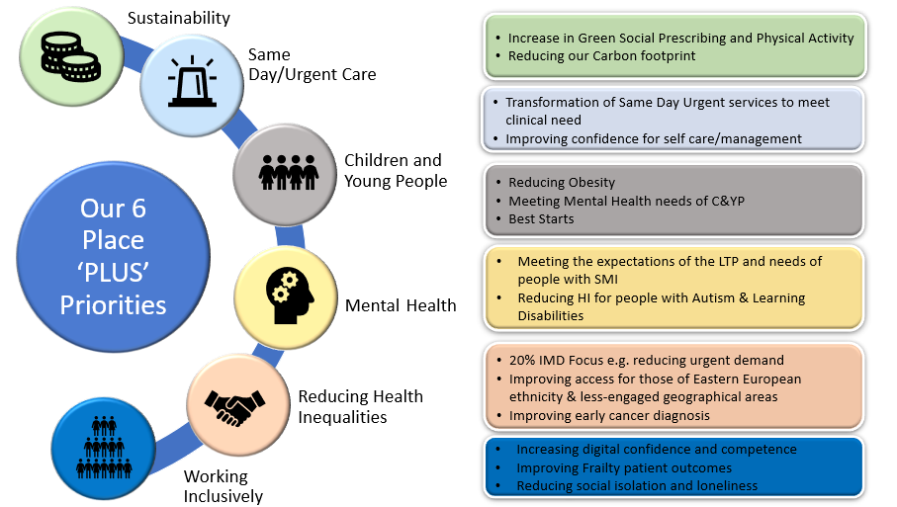

AIMS OF THE COMMUNICATION AND ENGAGEMENT STRATEGY
The aims of the communications and engagement strategy are:
- To establish open and maintain meaningful two-way communication with Bassetlaw citizens and stakeholders
- Raise the profile of the work being done by the Bassetlaw Place Based Partnership
- Strengthen partnerships. We need to engage with partners to support the dissemination of information through community networks and seek their input to shape our activity, for example with Healthwatch
- Engage with partners and stakeholders to evolve and develop the definition of ‘place’ in Bassetlaw
- Build, grow and maintain online and offline platforms for community engagement
- Ensure we develop these platforms with citizen input and look to co-produce wherever possible
- Ensure Bassetlaw people are invited to take part in conversations about shaping future plans through the Citizen Engagement Forum
- Work with Primary Care Networks to support them to deliver Bassetlaw Place priorities
- Ensure people can access useful and meaningful information to help them make healthy choices
- Celebrate and champion Bassetlaw at every opportunity.

COMMUNICATIONS AND ENGAGEMENT ACTIVITY
As a Place communications and engagement network we will:
- Devise a rolling communications and engagement plan
- Collectively develop robust and consistent communications plans and messages – both proactive and reactive – to help us address our key priorities
- Devise a media response protocol to ensure all partners are aware of media requests and can input into media responses where appropriate
- Look to use all analytic data to ensure maximum reach, engagement etc
- Always look to provide accessible information
- Ensure all groups and sectors have their say at every opportunity and ask people how they want to shape future health and wellbeing provision in Bassetlaw

Ongoing collaborative projects include:
- Supporting citizens with the rising cost of living. A communications plan is being devised with a focus on reaching as many people as possible with relevant, salient advice at a time of national crisis
- Educating people in Bassetlaw about Bassetlaw Place. Provisional plans include a promotional video, pop-up Place roadshows, the introduction of health and wellbeing awards, spotlight on different partners and their contributions to the partnership
- Promoting collaborative working to prevent suicide in Bassetlaw
- Celebrating Bassetlaw – looking for opportunities to champion the district and shout about the amazing work that goes on (there is obviously overlap with roadshows, awards etc).

What does success look like?
- Ability to measure awareness of Bassetlaw Place Based Partnership
- Effective collaborative working with partners
- Campaign success.

